Result Analysis

In our comprehensive study to predict wine quality using physicochemical attributes, we assessed four distinct classification models: AdaBoost, Decision Tree, Random Forest, and XGBoost. Our primary aim was to evaluate the efficacy of each model not just based on accuracy, but also through a variety of performance metrics that offer deeper insights into their classification prowess.

Model Performance Overview:

From a holistic standpoint, the models showcased closely clustered accuracy rates. AdaBoost led the pack with 76.56%, closely followed by Random Forest at 75.94%, XGBoost at 75.00%, and the Decision Tree at 74.69%. The tight range of these accuracies underscores the quality of the dataset and the suitability of the chosen models.

Confusion Matrix Insights:

A deep dive into the confusion matrices for each model revealed nuanced patterns in their predictions. While each model demonstrated unique strengths and weaknesses, a common theme was the challenge posed by wines rated 5. This particular rating seemed to be a point of misclassification across the board, hinting at its inherent intricacy. Shown below is the confusion matrix for Adaboost.

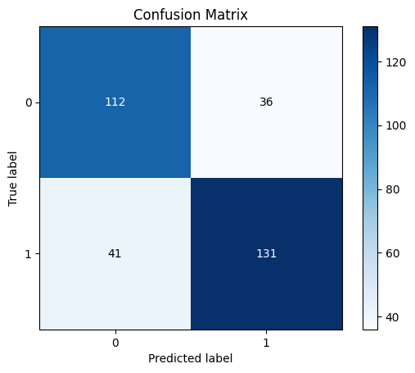

Precision, Recall, and F-statistic:

The ensemble models, namely Random Forest, AdaBoost, and XGBoost, consistently showcased robust performances across these metrics. They exhibited particular adeptness with wines rated 6 and 7, the most prevalent in our dataset. The Decision Tree, while simpler in its construct, held its ground commendably, but, like its counterparts, found wines rated 5 challengings. Below is the Adaboost classification report.

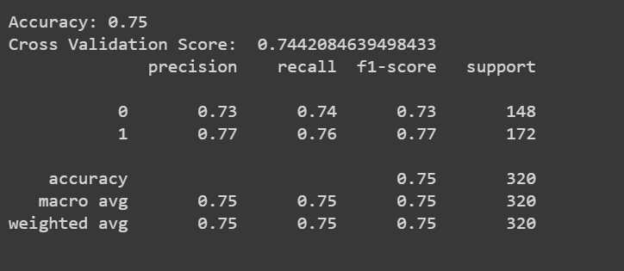

ROC and Precision-Recall Curves:

Visual representations in the form of ROC and Precision-Recall curves further illuminated the models' performances. The ensemble models, with their complex architectures, invariably exhibited higher AUC values, indicating a harmonious balance of precision and recall across diverse classification thresholds. As shown below, Adaboost had the most accurate curves out of the other models.

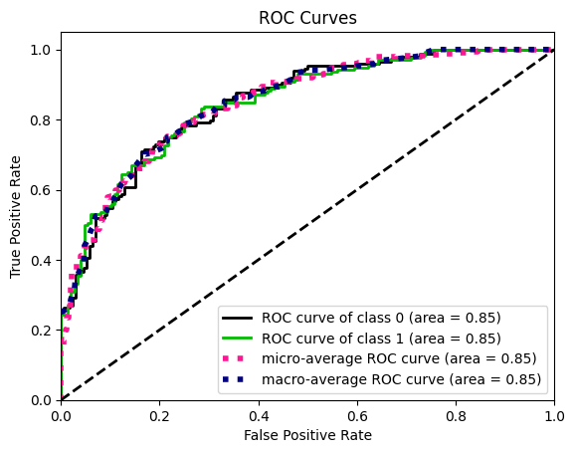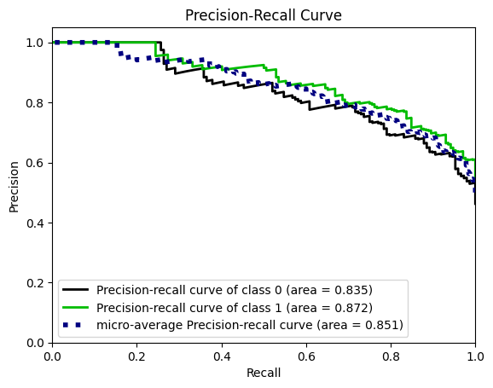

Comparative Analysis and Conclusion:

While each model brought its unique merits to the fore, the ensemble models, particularly AdaBoost with its slight edge in accuracy, emerged as standout performers. Their ability to leverage multiple learning algorithms provides them with a robustness that's challenging to parallel. However, Random Forest and XGBoost, with their tree-based ensemble mechanisms, were closely competitive, making them equally viable choices for such tasks.

The Decision Tree, while slightly trailing in terms of raw metrics, offers the advantage of interpretability. Its decisions can be visualized and understood, making it valuable in scenarios where explainability is paramount. Below is the Adaboost decision tree.

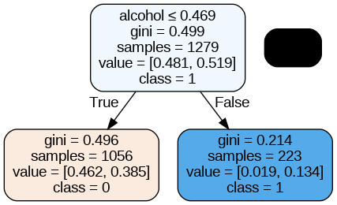

In wrapping up, while AdaBoost narrowly clinched the top spot in terms of raw performance, the choice of model in a real-world scenario would be influenced by additional factors such as interpretability, computational resources, and specific project requirements. The key takeaway is the importance of a holistic evaluation, where accuracy is just one piece of the puzzle. A comprehensive assessment, considering varied metrics and visual representations, is imperative to truly gauge a model's efficacy and applicability.